Session 2025-2026

Vision: To be a well-known centre for pursuing computer education through innovative pedagogy, value-based education and industry collaboration | Mission: To establish learning ambience for ushering in computer engineering professionals in core and multidisciplinary area by developing Problem-solving skills through emerging technologies.
Program Educational Objectives of the program (PEO): (broad statements that describe the professional and career accomplishments)
PEO1 | Preparation | P: Preparation | Pep-CL abbreviation pronounce as Pep-si-lL easy to recall
PEO2 | Core Competence | E: Environment (Learning Environment)
PEO3 | Breadth | P: Professionalism
PEO4 | Professionalism | C: Core Competence
PEO5 | Learning  Environment | L: Breadth (Learning in  diverse areas)

Program Outcomes (PO): (statements that describe what a student should be able to do and know by the end of a program)
Keywords of POs:
Engineering knowledge, Problem analysis, Design/development of solutions, Conduct Investigations of Complex Problems, Engineering Tool Usage, The Engineer and The World, Ethics, Individual and Collaborative Team work, Communication, Project Management and Finance, Life-Long Learning
PSO Keywords: Cutting edge technologies, Research

“I am an engineer, and I know how to apply engineering knowledge to investigate, analyse and design solutions to complex problems using tools for entire world following all ethics in a collaborative way with proper management skills throughout my life.” to contribute to the development of cutting-edge technologies and Research.

Integrity: I will adhere to the Laboratory Code of Conduct and ethics in its entirety.

Name and Signature of Student and Date
(Signature and Date in Handwritten)

Disha Angalwar
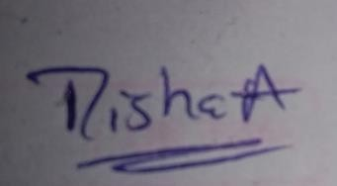

Session | 2025-26 (EVEN) |  | Course Name | JAVA FSD Lab
Semester | 4 |  | Course Code | 23ADS1407
Roll No | 4 |  | Name of Student | Disha Angalwar
Practical Number |  | 02
Course Outcome |  | Implement Java programs implementing control structures, searching (Linear Search), sorting (Bubble Sort), and object-oriented programming concepts such as inheritance and polymorphism.
Aim |  | WAP to demonstrate inheritance in java.
Problem Definition |  | 1.Problem Statement for single inheritance: Library Book Management  Create a base class Book with data members bookId, title, and author.  Create a derived class IssuedBook that adds issueDate and returnDate.  Write a Java program to display issued book details using single inheritance property.  2.Problem Statement : Online Shopping System Design a base class Product with attributes productId, productName, and price.  Create a derived class Electronics that adds warrantyPeriod.  Create another derived class Clothing that adds size and fabricType. Implement methods to display product details
Theory  (100 words) |  | Inheritance is a core concept of Object-Oriented Programming (OOP) where a child (derived) class acquires properties and methods of a parent (base) class.  It helps in code reusability, reducing duplication and improving efficiency.  It supports a hierarchical relationship, making programs more structured and organized.  The child class can add new features or modify existing ones using method overriding.  In Java, inheritance is implemented using the extends keyword.  Types of inheritance include single, multilevel, hierarchical, multiple (via interfaces), and hybrid.  It also enables polymorphism, especially runtime polymorphism, improving flexibility.  Inheritance makes code easier to maintain, extend, and debug..

Procedure and Execution | Algorithm: Library Book Management (Single Inheritance)  - Start  - Create a base class Book  - Declare data members: bookId, title, author  - Create a method to input and display book details  - Create a derived class IssuedBook that extends Book  - Add new data members: issueDate, returnDate  - Create a method to input and display issued book details  - In the main method:  - Create an object of IssuedBook  - Call methods to input book and issue details  - Display all details  - End  - information.  - Stop  2. Algorithm: Online Shopping System (Hierarchical Inheritance)  - Start  - Create a base class Product  - Declare data members: productId, productName, price  - Create a method to display product details  - Create a derived class Electronics that extends Product  - Add data member: warrantyPeriod  - Create a method to display electronics details  - Create another derived class Clothing that extends Product  - Add data members: size, fabricType  - Create a method to display clothing details  - In the main method:  - Create objects of Electronics and Clothing  - Input their details  - Call display methods to show product information  - End
(100 Words)
Code 1:
import java.util.Scanner;
class Book {
int bookId;
String title;
String author;

void inputBook() {
Scanner sc = new Scanner(System.in);
System.out.print("Enter Book ID: ");
bookId = sc.nextInt();
sc.nextLine(); // consume newline

System.out.print("Enter Title: ");
title = sc.nextLine();

System.out.print("Enter Author: ");
author = sc.nextLine();
}

void displayBook() {
System.out.println("\nBook ID: " + bookId);
System.out.println("Title: " + title);
System.out.println("Author: " + author);
}
}

class IssuedBook extends Book {
String issueDate;
String returnDate;

void inputIssuedBook() {
Scanner sc = new Scanner(System.in);

System.out.print("Enter Issue Date: ");
issueDate = sc.nextLine();

System.out.print("Enter Return Date: ");
returnDate = sc.nextLine();
}

void displayIssuedBook() {
displayBook(); // calling base class method
System.out.println("Issue Date: " + issueDate);
System.out.println("Return Date: " + returnDate);
}
}

public class LibraryManagement {
public static void main(String[] args) {
IssuedBook ib = new IssuedBook();

// Input details
ib.inputBook();
ib.inputIssuedBook();

// Display details
ib.displayIssuedBook();
}
}

Code 2:
import java.util.Scanner;

class Product {
int productId;
String productName;
double price;

void inputProduct() {
Scanner sc = new Scanner(System.in);

System.out.print("Enter Product ID: ");
productId = sc.nextInt();
sc.nextLine(); // consume newline

System.out.print("Enter Product Name: ");
productName = sc.nextLine();

System.out.print("Enter Price: ");
price = sc.nextDouble();
}

void displayProduct() {
System.out.println("\nProduct ID: " + productId);
System.out.println("Product Name: " + productName);
System.out.println("Price: " + price);
}
}

class Electronics extends Product {
int warrantyPeriod;

void inputElectronics() {
Scanner sc = new Scanner(System.in);

System.out.print("Enter Warranty Period (in years): ");
warrantyPeriod = sc.nextInt();
}

void displayElectronics() {
displayProduct();
System.out.println("Warranty Period: " + warrantyPeriod + " years");
}
}

class Clothing extends Product {
String size;
String fabricType;

void inputClothing() {
Scanner sc = new Scanner(System.in);

sc.nextLine(); // consume newline if needed
System.out.print("Enter Size: ");
size = sc.nextLine();

System.out.print("Enter Fabric Type: ");
fabricType = sc.nextLine();
}

void displayClothing() {
displayProduct();
System.out.println("Size: " + size);
System.out.println("Fabric Type: " + fabricType);
}
}

public class OnlineShoppingSystem {
public static void main(String[] args) {
Electronics e = new Electronics();
Clothing c = new Clothing();

System.out.println("Enter Electronics Details:");
e.inputProduct();
e.inputElectronics();
e.displayElectronics();

System.out.println("\nEnter Clothing Details:");
c.inputProduct();
c.inputClothing();
c.displayClothing();
}
}

Output 1:
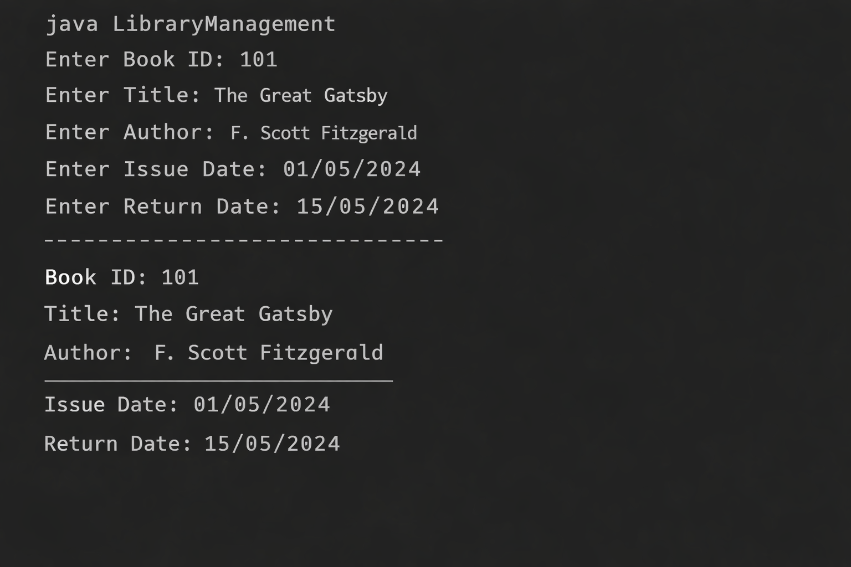

Output 2:
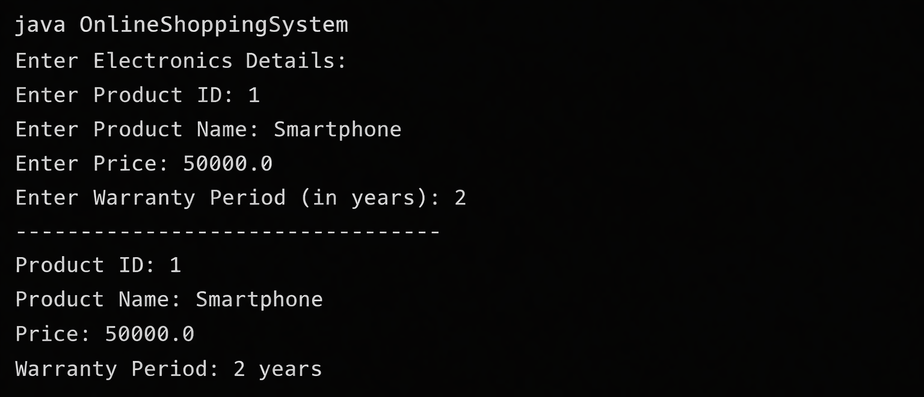

Output Analysis

Github link
Output Analysis: Library Book Management
- The program successfully takes input for book details (ID, title, author) and issued details (issue date, return date).
- It demonstrates single inheritance, where IssuedBook accesses properties of Book.
- The output shows that both base class and derived class data are displayed together.
- The function call from derived class to base class (displayBook()) works correctly.
- The program confirms proper data flow and reuse of code through inheritance.

https://github.com/dishaangalwar84/JavaFSD
Plag Report:

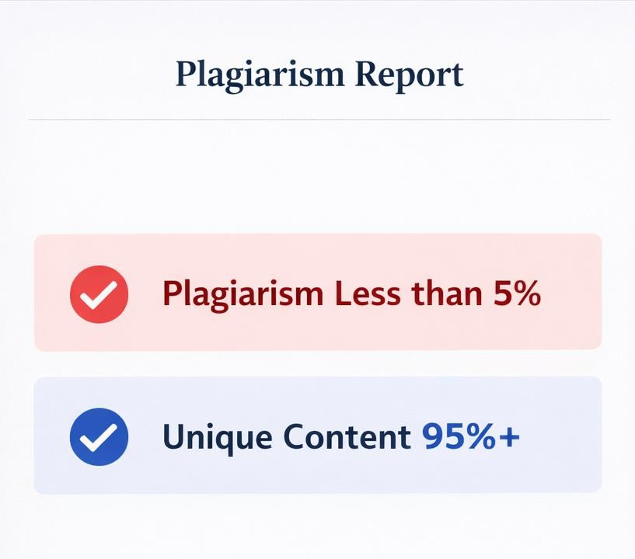

Conclusion:
In this practical, we learned the concept of inheritance in Java and how it helps in code reusability.
We implemented single inheritance using the Library Book Management system.
We also implemented hierarchical inheritance using the Online Shopping System.
We understood how base class properties and methods are reused in derived classes.
We learned about extending classes, method calling, and data sharing between classes.
Overall, this practical improved our understanding of OOP concepts and program structuring..
Date: 10/4/26
Faculty Signed Observation practical:

